**DS3580 PP3 Abdullah Alajaj**

**4/15/2018**

**Polling Server**

In this program we are creating prototype opinion polling system by developing distributed application based on RMI. There are two sides of such system, clients’ side where people can votes and server side where votes get collected.

When the server run, it create a registry service to make the connection available to all clients and keep total votes count updated. This way, multiple clients can votes or disconnect the voting server without any effect to the data or the server itself.

On the other hand, each client can open their API on the same time and cast as much vote as they wish without interruption. There are three choices to this voting system either Y for yes, N for no or D for don’t care. Any other answer will be rejected by the server without effecting total count. After each vote you will be asked if you want to vote again or not, this will allow every client API to multicast their vote. Last, you have the option to view total voting count which will be updated to the last vote you cast.

**Flow diagram:**

Client Server

Create or find Registry

Lookup Registry

Accept connection

Send total count

Connected

Object Registry

Receive or reject vote

Send Vote

**Vote again**

Receive Total count

Client Interface

Server Interface

Multiple clients on the same time

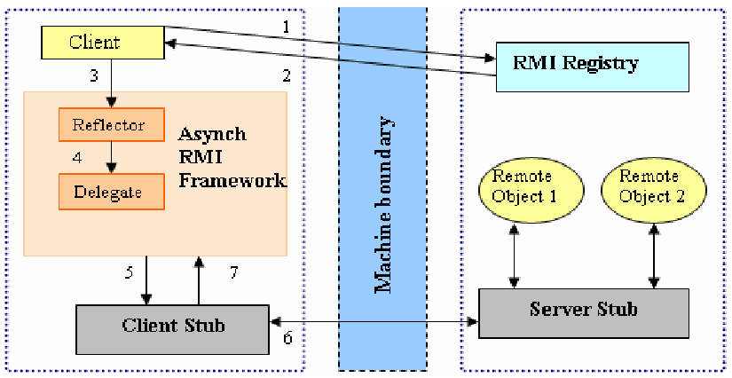

**Functions Description:**

**Compiled and executed:**

* Unzip “program 3 – Alajaj” folder then open NetBean IDE (prefer 8.2 version)
  + From top Manu bar : file >> (file location)>>(choose )

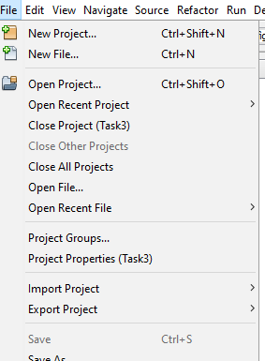

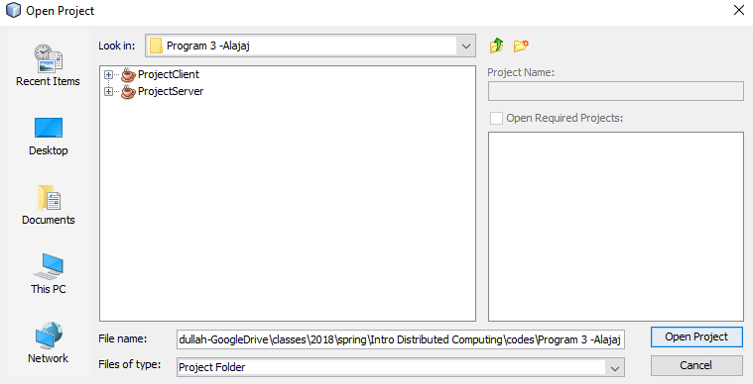

**To compiled the code:**

* I test it through local network and on the same PC using windows PowerShell , NetBeans and command prompt in windows 10 Home Version 1709
  + The easy way to open with the correct path on PowerShell is shift + right click in src folder for ProjectServer << open PowerShell window here
  + For command prompt, Go to the desktop search bar and type “cmd”. To set correct path use cd = “ “ where inside “” the location of the src file for ProjectClient.
  + Also, you can copy the PorjectClient folder to you desktop and run it on NetBeans as second client

Note:

* if the (classname).class does not exist then you can create one using this code Javac (the class name you want to compile).java
* You must run the server before the clients.
* Make the Server run on PowerShell and Client-1 run on command prompt and Client-2 on NetBeans or any way you like. Do not run both codes on the same program windows.

**Code test result:**

Let

Client to be A

Server to be B

B First invoke method object registry, A try to remote connect using RMI registry lookup. The order in which they run is important. When connection establish A can start voting as much as she/he wanted. There are only three choices. If A submit invalid vote B will reject it. On the end, A has the choice to display total voting count or not. B will continue run even if A disconnect. A can connect and continue voting again.

**One-To-One:**

* Running B first and A second: - A can start vote and B will keep track of total vote and send back the total result or reject incorrect entry.

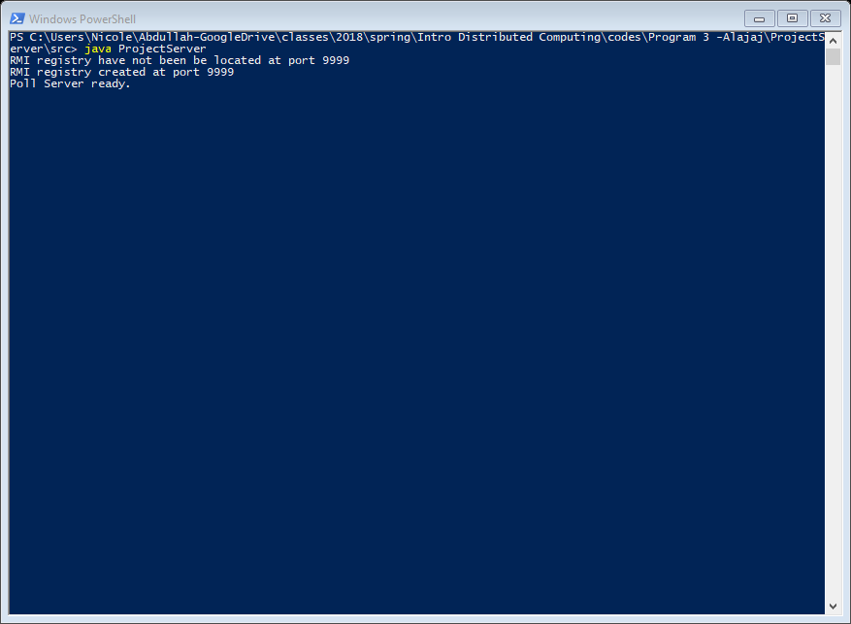

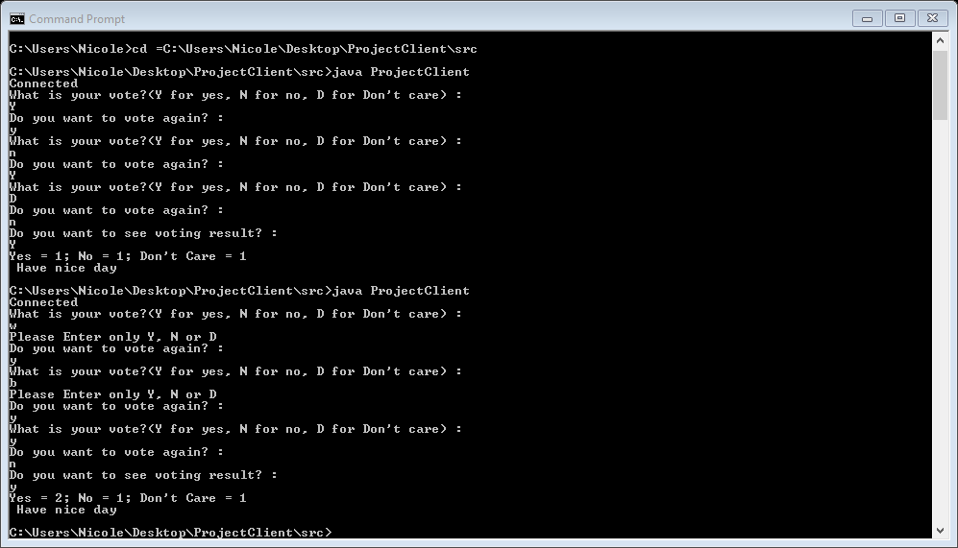

**Many-To-One:**

* Same as one-to-one but with two clients. Voting count continue from first test.
* From the result, we see that A1 received total votes when she/he last cast their vote is different from total votes count that A2 received.



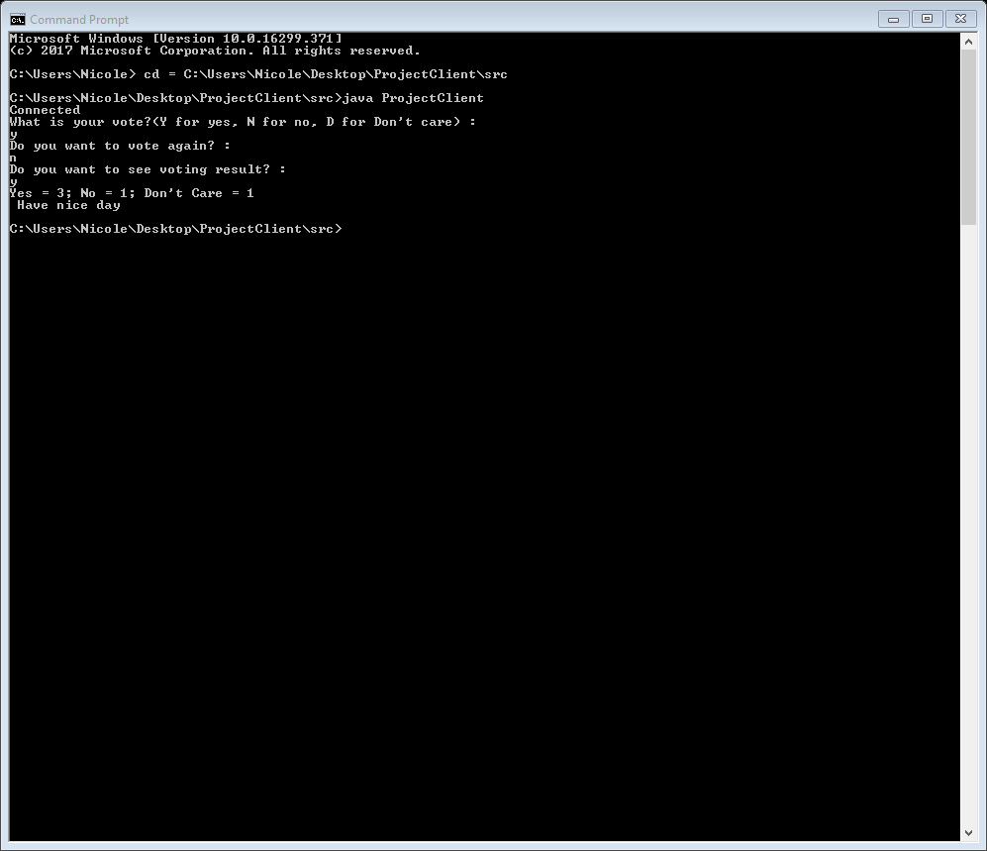

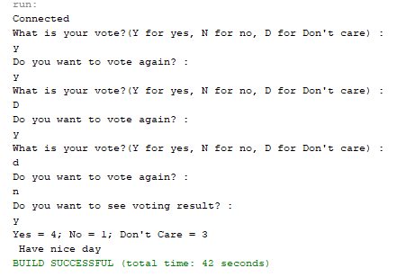

Error when trying to connect before running the polling server

